  - Writing scenario-based exam questions

This activity will help you create a new problem or scenario-based exam question, perhaps to use in an open-book exam context. This can be based around your existing generic or closed-book exam question or you could start from scratch using your learning outcomes. What you are aiming for is a well-defined question that assesses the skills or knowledge that students acquired as part of your course and that enables them to demonstrate higher level thinking in relation to this learning (See Appendix 1).
NB: Open book exam questions should be devised to assess the interpretation and application of knowledge, comprehension skills, and critical thinking skills. These higher-level capabilities depend on the ‘lower’ levels such as knowledge recall or comprehension so will implicitly test those as well.
EXAMPLE
The example below, used as the basis for the activity, shows how an original closed book exam question can be re-framed as a scenario/problem based open book question:
Learning Outcome:
By the end of this module you will be able to compile contingency plans for use in a professional environment.
Original ‘closed book’ question:
Outline the key elements required in a contingency plans for developing effective flood defences in in the UK.

Alternative scenario-based open book question:
You are a hydrologist working for a regional development agency with responsibility for a substantial river basin.​ You have been asked to produce a disaster recovery plan in case of a serious emergency leading to mitigations and remediation​ in the event of a serious flooding incident that affects more than 50% of your area.​ Please provide this plan in less than 2000 words with appropriate references and headings.

How do you get from the generic question to the

If you look at the anatomy of the generic (closed book?) question it consists of:
- student action: what the student needs to do in the assessment task [You have been asked to produce a disaster recovery plan]
- the object of the student action [in case of a serious emergency leading to mitigations and remediation​]
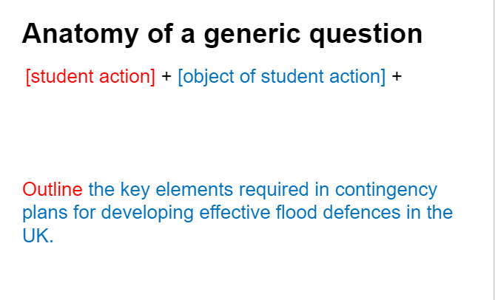

If you look at the anatomy of the open book exam question it consists of:
- a context [You are a hydrologist working for a regional development agency with responsibility for a substantial river basin]
- student action: what the student needs to do in the assessment task [You have been asked to produce a disaster recovery plan]
- the object of the student action [in case of a serious emergency leading to mitigations and remediation​]
- the scope of the student action [in the event of a serious flooding incident that affects more than 50% of your area.].
- instructions such as word limit and referencing [Please provide this plan in less than 2000 words with appropriate references and headings]

So as you go through the process of creating your open book exam question (worksheet below if you find this useful) you can think of the final questions in terms of a ‘formula’ as follows:
[Context] + [student action] + [object of student action] + [scope of action] + [instructions such as word limit and referencing]

Of course, the elements can be in any order!

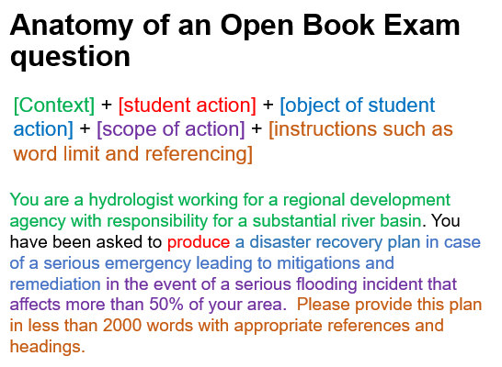

WORKSHEET
The steps below will help you to construct your open book exam question.

1 | What is your existing question (if appropriate)  Example: Outline the key elements required in contingency plans for developing effective flood defences in in the UK.
2 | What learning do you need to assess?  What learning outcome/s does the learner need to meet in the assessment? Alternatively, what learning outcome does your existing exam question ask the learner to demonstrate?  Example: By the end of this module you will be able to:  Compile contingency plans for use in a professional environment.
3 | Identify appropriate action verb. Does your learning outcome contain an action verb that describes how the learner can demonstrate this learning at the appropriate level? If it is not precise or directive enough (i.e. if it says something like ‘understand’) rephrase it into something more meaningful. Try to identify several alternatives to choose from in the final version. See Appendix 1.  Example: Compile (alternatives could be ‘produce’, ‘design’, ‘develop’, ‘create’)
4. | Determine the object of the verb.  Start with the generic object from the learning outcome and think how you can make this more specific.  Example:  - Generic: Contingency plans for use in a professional environment​  - Specific to this exam question: a disaster recovery plan related to flooding.
5 | Determine a context in which the learner could demonstrate this learning.  In order to make the exam question meaningful and to enable the learner to demonstrate independent and critical thinking, you will need to provide some context in which they can think through the problem.  Example: You are a hydrologist working for a regional development agency with responsibility for a substantial river basin.​
6. | What evidence does the learner need to produce to demonstrate their learning?  What format best suits the task? Revisit your proposed list of action verbs from step 3 and choose the most appropriate.  Example: Produce a disaster recovery plan in case of a serious emergency leading to mitigations and remediation.
7. | What is the remit or scope of the exercise?  You will want to specify the parameters or scope of the task.  Example: In the event of a serious flooding incident that affects more than 50% of your area.​
8. |  | What is your final scenario or problem-based question?  [Context] + [student action] + [object of student action] + [scope of action] + [instructions such as word limit and referencing]

More ideas and variables can be found in Appendix 2

Reflection:
Perhaps you can ask a colleague to review your question/s and consider:
- How well it measures what you need it to measure (perhaps in relation to your original question)?
- Do you have any concerns e.g. academic integrity, marking load and if so how might you address these?
- What resources will you suggest students can use and how should they use them? Think about how they will select, evaluate and acknowledge sources.

More ideas: UCL Designing open book exams toolkit
https://www.ucl.ac.uk/teaching-learning/publications/2021/feb/designing-open-book-exams#Table%202

Appendix 1: higher order thinking

You will need to use directive verbs so that the student knows what capabilities and so on they are being asked to demonstrate. Try to avoid vague terms like ‘discuss’. Blooms taxonomy provides categories of learning and related action verbs. This verb chart provides a host of ideas: https://tips.uark.edu/blooms-taxonomy-verb-chart/

Lower order thinking questions
- targets memory and ask students to recall, list, name, define, repeat, etc.
- targets comprehension and ask students to describe, explain, recognize, summarize, etc.
Higher order thinking question
- targets application and ask students to solve, use, examine, compare, contrast, relate, etc.
- targets analysis and ask students to infer, explain, differentiate, distinguish, relate, etc.
- targets synthesis (creation) and ask students to develop, organize, design, create, integrate, etc.
- targets evaluation and ask students to judge, critique, justify, recommend, assess, etc

This diagram below from Blooms taxonomy also provides a range from lower level (concrete) to higher level (abstract) thinking which can help you identify appropriate action verbs associated with the levels of learning that students need to demonstrate. For example, you would not want to have metacognitive type learning outcomes at Level 4 and factual at Level 6. Although this is depicted as discrete steps, it may not always be the case that procedural knowledge is more abstract than all conceptual knowledge. This is something you will need to determine in relation to your disciplinary context.

 | Concrete / Lower |  |  |  |  | Abstract/ Higher
Learning objective | FACTUAL |  | Conceptual | Procedural | Metacognitive
Remember | List |  | Match | Recall | Reproduce
Understand | Illustrate |  | Classify | Exemplify | Predict
Apply | Respond |  | Produce | Carry out | Solve
Analyze | Identify |  | Differentiate | Integrate | Transform
Evaluate | Select |  | Rank | Review | Assess
Create | Generate |  | Assemble | Design | Construct
Appendix 2: Variables to adapt

Thanks to Sally Brown and Kay Sambell: https://sally-brown.net/):

Action verb | Object | Outcome/evidence of achievement
Articulate | the central aspects of a problem | a case study, offering a variety of reasoned solutions, with a rationale for each and a personalised recommendation
Argue | For a particular solution based on a range of complex contextual factors a reasoned rationale for this choice. | an executive summary with appendices.
Formulate | Your plans for project planning and management in a highly time-constrained environment where all tasks appear equally urgent. | A prioritised action plan with milestones of achievement and measurable indicators of success.
Synthesise | synopses of multiple and diverse sources including text, image and data which can explain a particular phenomenon discussed within a programme | Press releases suitable for both (a) tabloid and (b) ‘long read’ newspaper journalists.
Critique | three perspectives on or readings of an identified text, choosing one that is most convincing to you and giving your reasons for this choice. | A presentation for a specialist conference in your field.
Provide | A rationale for a course of action taken in a professional setting, illustrating this with appropriate, relevant and current formal and informal publications. | An email (no more than 1,000 words plus references and hyperlinks) to your manager who has asked you to provide evidence-based justification for your planned course of action.
Research | An area of innovation, and argue for its uptake, drawing conclusions from your sources of information for the likelihood of the initiative’s success. | A five-minute pitch to a prospective funder who is reviewing your proposal in competition with several others.

